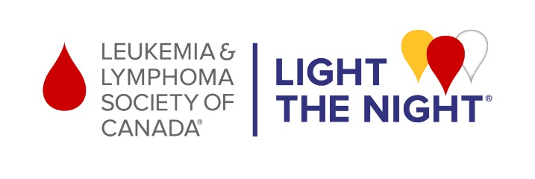

Dear Family and Friends,

I recently accepted the challenge to raise funds to support The Leukemia & Lymphoma Society of Canada’s Light The Night event on October 21, 2023.

When you or someone you love hears the words “you have cancer”, it’s one of the darkest moments in your life. Light The Night celebrates cancer survivors, honours those we’ve lost and gives hope to those facing a blood cancer. It’s more than a walk, more than an event, and more than a fundraiser. The Light The Night community shines as a beacon of hope in time of despair, a sanctuary of solidarity in a place of loneliness and a haven of support when you don’t know where to turn.

Helping the blood cancer community is near and dear to my heart. The money raised helps fund research and critical programs and services that help support Canadians at every step of their blood cancer experience.
I’ve made a personal donation of $[insert amount] to kick-off my fundraising efforts. Participating and donating is my way of impacting the lives of those touched by cancer. But I cannot do it alone.
I need your help to make a difference. Please consider donating what you can at [insert personal page link]. Your support means everything to me and to those affected by blood cancers.

You are more powerful than you know…Your light dispels darkness. Your light defies despair. Your light defeats loneliness. You Make Everything Possible!

To learn more about Light The Night and its impact in the community, please visit www.lightthenight.ca.

With thanks,
[First Name]

